6th Annual Rabbit Show at the Walker County Ag Festival
Saturday, Sept. 25, 2021
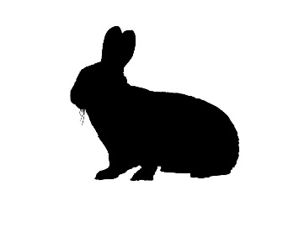
Open to all youth, ages 5-18. Online entries are due to becky.forrester@glschools.org by 7pm on Sept.18. There will be no entry fee this year!
Check in is Friday night , Sept. 24 from 5:00 – 8:00 pm. Rabbits will spend the night at the Ag Center. Judging will begin at 8am on Saturday.
Rules for rabbit show
- Rabbits must be at least 8 weeks of age
- No rabbit who show sign of disease, sickness or neglect will be allowed to enter show
- Youth participants must provide their own wire cages. No pet carriers or taxis.
- Rabbits must have access to clean water in a water bottle at all times
- Youth must handle their own rabbits and be present during judging
- All breeds are eligible to enter
- Any mixed breed rabbit or of unknown breed must be shown in commercial/pet class
Ribbons will be awarded to all participants. Ribbons will be awarded to Best of Class (sex, age) and Best of Breed. Rosettes will be awarded to Best of Show and Reserve Best of Show.
Email entries to becky.forrester@glschools.org by 7pm Sept. 24. Each entry must include the following information: Name of youth, address, phone number, school, grade, breed of rabbit, sex of rabbit, age of rabbit, ear tattoo number if available

Sponsored by The Gordon Lee FFA Alumni and Melon Patch Farms

